

CAPSTONE PROJECT REPORT
Report 1 – Project Introduction

– Ho Chi Minh City, September 2026 –
Table of Contents
I. Record of Changes 3
II. Project Introduction 4
1. Overview 4
1.1 Project Information 4
1.2 Project Team 4
2. Product Background 4
3. Existing Systems 4
3.1 SAP Extended Warehouse Management 4
3.2 Microsoft Dynamics 365 Supply Chain Management 5
3.3 Odoo Inventory 5
3.4 Oracle NetSuite WMS 5
4. Business Opportunity 5
5. Software Product Vision 5
6. Project Scope & Limitations 6
6.1 Major Features 6
6.2 Limitations & Exclusions 6

I. Record of Changes
Date | A*  M, D | In charge | Change Description
15/09/2026 | A | Trương Lê Huy Hoàng | Initial version of the FSCM Project Introduction
24/09/2026 | M | Trương Lê Huy Hoàng | Revised Section 2-6
24/09/2026 | M | Nguyễn Thiện Nhân | Reviewing and update general information
*A - Added M - Modified D - Deleted

II. Project Introduction

1. Overview

1.1 Project Information
- Project name: FSCM – Short Shelf-Life FMCG Supply Chain Management and Distribution Coordination System with FEFO Optimization
- Project code: FA26SE083
- Group name: GFA26SE63
- Software type: Web Application and Mobile Application

1.2 Project Team
Full Name | Role | Email | Mobile
Le Thi Quynh Chi | Lecturer | chiltq6@fe.edu.vn
Nguyen Thien Nhan | Leader | NhanNTSE184555@fpt.edu.vn
Tran Ngoc Khiet | Member | tranngockhiet22062005@gmail.com
Doan Duc Hai | Member | beu2901@gmail.com
Vo Minh Son | Member | vominhson310805@gmail.com
Truong Le Huy Hoang | Member | hoanghuypeter1182004@gmail.com

2. Product Background
Short shelf-life FMCG products such as dairy, fresh bakery items, and chilled goods must be controlled by Batch/Lot and expiration date. Spreadsheets and general inventory tools can show stock totals, but they do not consistently determine which eligible batch should be allocated to an order. FIFO alone is insufficient because a later receipt may expire earlier than an older receipt.
The target operation is one FMCG distributor that manages a network of warehouses and supplies retail stores. The warehouses are operating locations in the same enterprise and are not divided into a fixed hierarchy. A Sales Representative creates the retail-store order, while the Retail Store Manager participates at receipt confirmation rather than order placement.
FSCM connects approved goods receipt, Batch/Lot inventory, offline sales ordering, order approval, ETA and MLOR eligibility checks, FEFO allocation across eligible warehouses, reservation, picking, dispatch evidence, and receipt reconciliation. Inventory increases only after Administrator approval; expired batches are locked; and the Retail Store Manager confirms the received batch and quantity, attaches a photo, and records discrepancies without creating retail-store inventory.

3. Existing Systems
The following products provide useful references for batch inventory, FEFO picking, and reservation. FSCM adopts relevant concepts while narrowing the solution to the project's retailer-order allocation problem.

3.1 SAP Extended Warehouse Management
Users: warehouse managers and warehouse operators. Relevant capabilities: batch stock, shelf-life expiration dates, warehouse execution, and delivery scheduling. Strength: mature control for complex enterprise warehouses. Gap for this project: its enterprise breadth and configuration effort exceed the focused MVP required for an SME distributor.
Official reference: https://help.sap.com/docs/SAP_ERP/34fc810a607e4ae5a287b6e233b8566f/f18ec95360267214e10000000a174cb4.html

3.2 Microsoft Dynamics 365 Supply Chain Management
Users: inventory, order, and warehouse teams. Relevant capabilities: sales-order inventory reservation, batch control, and warehouse reservation policies. Strength: integrated order and inventory visibility. Gap for this project: the project still requires its own explicit ETA-MLOR eligibility check and focused multi-branch allocation flow.
Official reference: https://learn.microsoft.com/en-us/dynamics365/supply-chain/inventory/reserve-inventory-quantities

3.3 Odoo Inventory
Users: inventory managers, warehouse operators, and sales users. Relevant capabilities: lot tracking, expiration dates, and FEFO removal strategies. Strength: a modular and comparatively accessible inventory workflow. Gap for this project: standard FEFO removal does not express the project's ETA-based MLOR filter, atomic reservation, and split fulfillment rules as one process.
Official reference: https://www.odoo.com/documentation/19.0/applications/inventory_and_mrp/inventory/shipping_receiving/removal_strategies/fefo.html

3.4 Oracle NetSuite WMS
Users: warehouse managers, order managers, and warehouse operators. Relevant capabilities: lot-numbered inventory, FEFO lot assignment, and expiry-date validation. Strength: FEFO support within a broader cloud ERP environment. Gap for this project: its broader ERP scope is not tailored to the project's lightweight SME workflow and documented FEFO-MLOR heuristic.
Official reference: https://docs.oracle.com/en/cloud/saas/netsuite/ns-online-help/article_161009052865.html

4. Business Opportunity
FSCM addresses the gap between spreadsheets or basic inventory tools and large enterprise warehouse systems. An FMCG distributor needs controlled receipt approval, Batch/Lot and expiry visibility, reliable allocation, and auditable dispatch and receipt evidence without adopting an oversized ERP solution.
The product first filters stock by service range, available quantity, committed receiving deadline, and retailer-SKU MLOR. It then applies FEFO across eligible batches, using distance and available quantity only as tie-breakers. Tentative allocations are rechecked before atomic reservation to prevent double-booking; if eligible stock is still insufficient, the retailer's partial-fulfillment policy determines how the remainder is handled.

5. Software Product Vision
For an FMCG distributor managing short shelf-life products across its warehouse network, FSCM is a web and mobile system for approved receipt, Batch/Lot inventory, sales-order processing, ETA-MLOR eligibility, FEFO allocation, reservation, picking, dispatch, and retail receipt reconciliation. The expected result is more consistent batch selection, fewer allocation conflicts, and an auditable flow from receipt to receiving evidence.
The solution uses React and Chart.js for the web portal, ASP.NET Core Web API for REST services, Flutter for the mobile application, and Azure Database for PostgreSQL for transactional data. The offline-first mobile flow uses SQLite, a local queue, and WorkManager synchronization. Azure Blob Storage stores evidence files; Microsoft Entra ID supports identity; PostgreSQL transactional outbox, a worker, and Azure Functions Timer Trigger support asynchronous and scheduled processing. Vercel, GitHub Actions, Azure Notification Hubs, Azure Monitor, Azure DNS, Azure Front Door, Web Application Firewall, and Azure Key Vault support delivery and operations.

6. Project Scope & Limitations
The MVP covers approved goods receipt, Batch/Lot inventory and date tracking, offline sales orders, order approval, ETA and MLOR eligibility, FEFO allocation across eligible warehouses, atomic reservation, picking, dispatch evidence, retail receipt reconciliation, controlled write-off, dashboard, notifications, and audit. Transportation coordination, forecasting, and other advanced functions remain optional.

6.1 Major Features
FE-01: Master data and access control. Manage SKUs, warehouses, retail stores, service ranges, retailer-SKU MLOR values, processing and transit-time configurations, users, and roles. Apply role-based permissions and audit relevant actions.

FE-02: Goods receipt and Batch/Lot inventory. The Warehouse Keeper records SKU, quantity, Batch/Lot, and expiration date. The system generates the Batch ID, and inventory increases only after Administrator approval.

FE-03: Batch date tracking. A daily date tracker changes batches from Normal to Near-date to Expired and prevents expired stock from being allocated or issued.

FE-04: Offline sales ordering. The Sales Representative views cached catalog and availability data, creates orders offline, stores them in a local SQLite queue, and synchronizes them through WorkManager when connectivity returns.

FE-05: Order approval and state control. The Administrator approves or rejects orders. The main order flow is Pending Approval → Confirmed → Dispatched; rejected orders are recorded as Rejected and do not enter allocation. When eligible stock is insufficient, the affected order line remains Awaiting Stock if partial fulfillment is not allowed, or records the reserved portion and the outstanding portion under the retailer policy. Order, order-line, and reservation outcomes are tracked separately, with RBAC and an audit trail for each change.

FE-06: Service-range, ETA, and MLOR eligibility. For each candidate warehouse and batch, the system checks available quantity and service range, then compares ETA with the committed receiving deadline: ETA must be less than or equal to the deadline. It separately checks remaining shelf life at arrival: EXP - ETA must be greater than or equal to m(c,s) x SL(s), where 0 < m(c,s) < 1. Only batches that pass both comparisons continue to FEFO ranking.

FE-07: FEFO multi-warehouse allocation. Combine eligible batches into one list and rank them lexicographically by earliest expiration date, then shorter distance, then greater available quantity. Allocate across multiple batches or warehouses when necessary to satisfy an order line. Record the tentative warehouse-Batch/Lot-quantity result and the allocation attempt outcome: Completed when its permitted reservation is committed, Insufficient Eligible Stock when no permitted reservation can be made, or Retry when a reservation conflict requires recalculation. Allocation Completed is distinct from order delivery Completed.

FE-08: Partial policy and atomic reservation. Recheck ETA and available-for-reservation before committing the tentative allocation; reserve the permitted warehouse-Batch/Lot quantities atomically using Optimistic Locking. On conflict, release the current attempt, reload inventory, and rerun allocation. Only after all eligible batches have been considered may the retailer policy allow partial fulfillment: reserve the available portion and backorder the remainder, or cancel only the remainder when cancellation is permitted and the retailer has agreed. If partial fulfillment is not allowed, do not reserve the incomplete allocation and keep the affected line awaiting stock. Record reserved, backordered, and cancelled quantities separately.

FE-09: Picking, goods issue, and dispatch evidence. Generate picking lists by warehouse, Batch/Lot, and reserved quantity. Reservation reduces available-for-reservation but does not reduce physical stock. The Warehouse Keeper picks the assigned batches, confirms quantities issued, and captures a dispatch photo; only goods issue decreases physical stock and moves the order to Dispatched. Record any picking discrepancy for review rather than silently substituting a batch.

FE-10: Retail receipt reconciliation. The Retail Store Manager scans or enters the batch, confirms the received quantity, captures a receipt photo, and records discrepancies against the dispatch record without creating retail-store inventory. Store the receipt reconciliation result separately from the core order state. Receipt confirmation does not automatically set the order to Completed; delivery completion belongs to the optional transportation module.

FE-11: Write-off, dashboard, notifications, and audit. Control write-off through available-quantity validation, photo evidence, and multi-level approval. Show Batch/Lot inventory, near-date ratio, warehouse and SKU filters, operational KPIs, notifications, and action history.
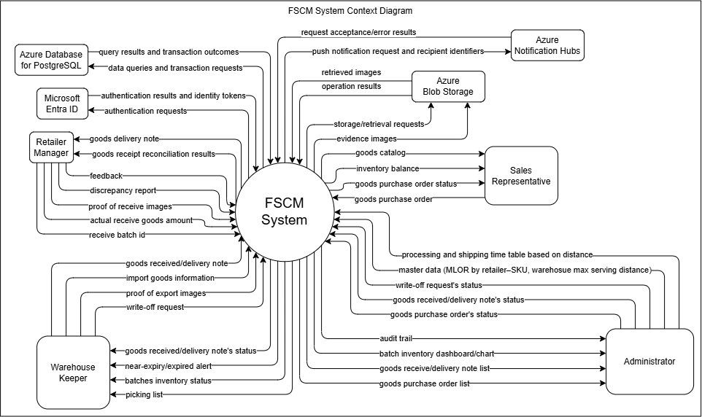

6.2 Limitations & Exclusions
LI-01: Enterprise and warehouse boundary. The system serves one FMCG distributor and its warehouse network. Warehouses are treated as peer operating locations rather than a fixed hierarchy, and the product is not a multi-tenant marketplace.

LI-02: Retail Store Manager boundary. The Sales Representative creates retail-store orders. The Retail Store Manager does not place orders but does confirm receipt, reconcile Batch/Lot and quantity, attach a photo, and report discrepancies.

LI-03: Retail-store inventory exclusion. Receipt reconciliation records the delivered Batch/Lot and quantity only. The system does not create or manage inventory, storage locations, point-of-sale stock, or shrinkage at the retail store.

LI-04: ETA and transportation boundary. ETA is an estimate used to test the receiving deadline and MLOR, not a guarantee of actual delivery time. Vehicle and driver assignment, route optimization, live GPS, cold-chain monitoring, delivery completion, and on-time-delivery KPI belong to the optional transportation module.

LI-05: Heuristic and shipment limitation. FEFO, distance, and available quantity form a lexicographic project heuristic; the system does not claim globally optimal cost or allocation across all orders. The MVP does not limit the number of warehouses per order or enforce a minimum shipment quantity, so small split shipments may occur.

LI-06: MLOR policy. MLOR is configured for each retailer-SKU with 0 < m(c,s) < 1. The system does not automatically reduce MLOR, extend the receiving deadline, or widen the service range when eligible stock is insufficient.

LI-07: Multi-warehouse and partial fulfillment. Using several batches or warehouses to fully satisfy an order line is not partial fulfillment. Only after all eligible stock has been considered does the retailer policy determine whether the available quantity may be reserved and the remainder backordered or cancelled with retailer consent.

LI-08: Offline boundary. Offline support covers Sales Representative catalog access, order capture, local queuing, and synchronization. Warehouse approval, allocation, reservation, dispatch, receipt reconciliation, and administration require server connectivity.

LI-09: Deferred advanced functions. Forecasting, MAPE, safety stock, promotions, OCR and LLM label processing, computer-vision shelf analysis, extended retail recall tracing, and optional transportation or cold-chain functions are outside the mandatory MVP.

LI-10: Technology boundary. The initial solution uses a modular application and REST APIs. Microservices, a dedicated API-management layer, and advanced event-streaming infrastructure are not required for the MVP.

